**HNBA commission system**

**System Modification Requirements Specification – (23-03-2017)**

Version 3.0

Table of Contents

1. Revision History 3
2. Introduction 3

Purpose 3

1. Overall Description 4

3.1. Background 4

Agency Management Process 4

Commission Calculation Process 5

Commission Calculate Rate Chart 6

Commission Calculate Rate Chart - Alternative 7

Overriding Commission Calculation Process 8

Overriding Commission Calculation Chart 9

Incentive Management Process 10

Banc assurance incentive process 10

Field Staff Incentive Process 11

FST allowance and target allowance 12

Group path level procedure GL/TL/AFM 13

Group path level procedure FM/AGFM/GFM 14

Group path level procedure SGFM 15 Group Incentive Criteria 16

Retainer Bonus GL/TL/AFM/FM/AGFM 17

Retainer Bonus GFM/SGFM 18

3.2 Objectives 19

3.2.1 Design Diagrams 19

Flow Chart 19

Agency Management 19

Data Gathering for Commission 20

Commission Calculation 21

Commission Overriding 22

User Interface Designs 23

Agent Personal Detail 23

Agent Other Detail 24

Agent Level Detail 25

Agent Commission / Commission Overriding Detail 26

Bank Assurance Detail 27

3.3. Reports 28

3.4 System Integration 29

3.5. Unsolved issues 29

3.6. Assumptions 29

# 1. Revision History

|  |  |  |  |
| --- | --- | --- | --- |
| Date | Version | Description | Author |
| 23/03/2017 | 1.0 | SRS | Janaka Indrajith  Suranga Kulawardane |
|  |  |  |  |
|  |  |  |  |

# 2. Introduction

## Purpose

The idea of this SRS is to finalize the requirement for new commission & Incentive processes for the purpose of automate manual process as much as possible and introduce new features such as dynamic agent hierarchy defining, More validations, New required reports etc..

# 3. Overall Description

## 3.1. Background

Currently HNBA commission system is using by the Finance & Marketing departments. Marketing staff is used to maintain agent management module & Life support service unit is maintaining the Commission module.

* **Agency Management Process**

In this process we are keeping all the details of agents such as personal details, Educational details, Commission details, Retainer details, Incentive details etc…

Agent maintain process will start just after marketing staff got a physical file which contain agent details. After receiving the file they should feed the same agent details to TCS application as well BISCoa application but only BISCoa data is used to maintain the agent module and commission module.

Since there are agent hierarchy maintain limitations, Manual uploads and system maintain difficulties we have decided to implement this new application with a dynamic way by considering the new features and system enhancements requested.

In here especially we have considered agent reporting hierarchy module with both vertically and horizontally defining.

* **Commission Calculation Process**

A commission is a form of payment to an agent in which the agent receives a percentage of the value of each transaction that a client makes.

For the commission calculation currently there is a batch process to update TCS receipts to BISCoa system. Then finance staff take the premium transfer report with transaction type and make the DPTS data set and upload to BISCoa system. Refunds / Cheque returns / cancellations are manually updated to BISCoa.

So to reduce the no of manual processes we are rethinking the possible ways to automate the uploading processes.

**For** **TCS products** we have planned to update PID balance of new commission application by automatically taking receipts, sys vouchers, refunds, Cheque returns, cancellations from the TCS system.

**For Non-TCS products** respective division has to upload their DPTS details which makes by them self.

(E.g. – MRP, MCR, Takaful, Investment, My Freedom, Super Five, My Pension etc….)

Also we are introducing a dynamic rule engine interface to configure the commission rates them-self (with special rights) and according to that we are calculating to commission using above filtered income.

According to the discussions, we have decided to calculate commissions up to cover level currently it is up to product level. Cover level commission supposed to calculate after the normal commission calculation since this is an addition commission.

**Commission Calculation Rate Chart**

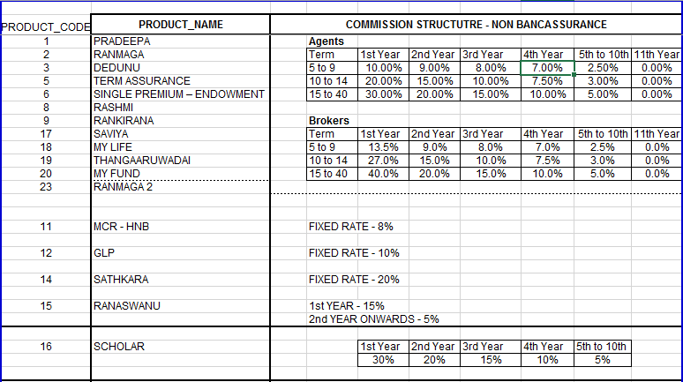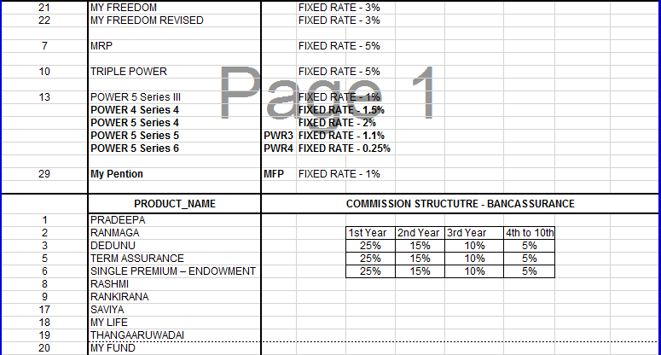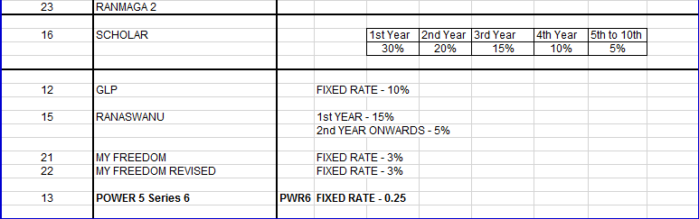

**Commission Calculation Rate Chart - Alternative**

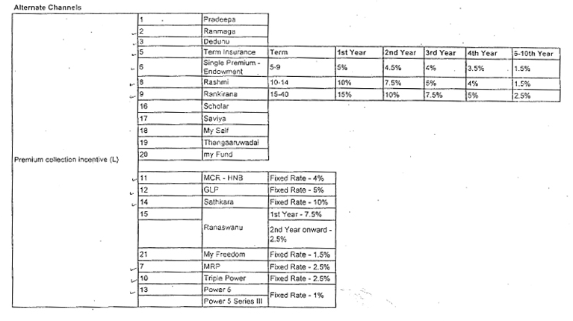

* **Overriding Commission Calculation Process**

An extra or additional commission, which paid to an agent or broker on business sold by subagents in his or her territory.

This happens from individual level to group level (E.g. from Field Advisor to GL or TL). In between individual level no overriding take place. Also there are some levels which cannot assign for overriding, system allows to configure those levels (Eg.GL to TL) and there is something called GAP which means overriding commission happens by passing levels.

With this module we are maintaining the hierarchy both horizontal and vertical because Some people has to wait long time to get a promotion because of their reporting level won’t allow since if they allow that they will miss the commission from the promoted party. So then even after the promotion we can assign a portion of the commission from promoted party to their previous superior.

Commission overriding rate chart

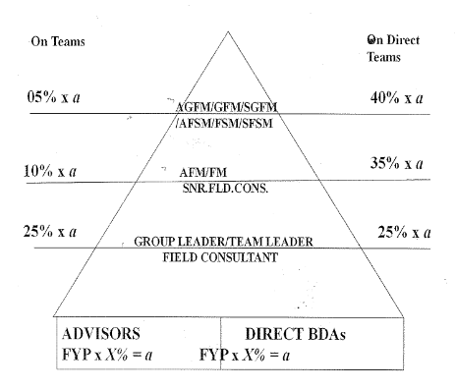

Example for proposed Commission overriding feature in graphically

According to the example GL or TL getting overriding commission from advisor as usual then the advisor promote to individual level (FC / AFC) after this GL/TL will not have overriding anymore as a solution for this we are implementing a feature for that GL/TL still can have some percentage of overriding commission. (Percentage still not decided)

?

FC / AFC etc…

GL/TL etc…

Promotion Current Overriding

Advisor

* **Incentive Management process**

Basically there are two incentive methods named as Bank Assurance & Field Staff incentives. In the Bank Assurance incentive method currently there are two incentive schemes as follows. As well as field staff incentive process can bifurcate such as Individual and Group paths. Under these two categories there are allowance types such as FST allowance, Target allowance, Retainer allowance, Advisor development allowance etc… also there are some defined levels such as GL, TL, SFC, FC, FSM and by considering all those given Categories, Allowance Types, Levels there are several calculation tables which is describing under the Field Staff incentives.

**Bank Assurance Incentive Process**

1. Incentive scheme for BAO’s

* Minimum achievement of NOP for the month 3, 4, 5 etc…
* Compulsory except for BAO’s less than one year

|  |  |
| --- | --- |
| NBP (FST + FYP) | Reimbursement of Business expenses |
| Achievement 80% - 100% | 1% of the NBP Achievements |
| Achievement 100% - 110% | 2% of the NBP Achievements |
| Achievement 110% - 120% | 3% of the NBP Achievements |
| Achievement 120% & Above | 4% of the NBP Achievements |

1. Incentive scheme for Executive

10% overriding commission of the attached BAO’s incentives in the respective cluster in addition to receivable from their own branches.

**Field Staff Incentive Process**

Allowances Types can categorize as follows

* Individual
  + FST Allowance - Monthly Payment
  + Target Allowance - Yearly Payment
* Group
  + Retainer Allowance - Monthly Payment
  + Retainer bonus allowance - Yearly Payment
  + Retainer arrears - Yearly Payment
  + Advisor development allowance - Monthly Payment
  + Group achievement - Monthly Payment

**Individual**  **Group**

Senior Group Field Manager

Senior Financial Services Manager

Group Field Manager

Financial Services Manager

Assistant Group Field Manager

Assistant Financial Services Manager

Field Manager

Senior Field Consultant

Assistant Field Manager

Field Consultant

Senior Field Executive

Senior Insurance Advisor

Field Executive

Insurance Advisor

Senior Insurance Advisor

Insurance Advisor

**FST Allowance (Individual)**

Advisors who are within 1st year from the date of appointment will get a FST allowance on a monthly basis, Maximum allowance will be Rs. 2500 (Configurable). After one year of the service period they will continue to enjoy the existing Target allowance.

|  |  |  |  |
| --- | --- | --- | --- |
| **No** | **Policies** | **FST Amount** | **FST Allowance** |
| 1 | 2 | <5000 | 750 |
| 2 | 2 | <7500 | 1000 |
| 3 | 2 | <10000 | 1250 |
| 4 | 2 | <12500 | 1500 |
| 5 | 2 | <15000 | 1750 |
| 6 | 2 | <25000 | 2500 |

**Target Allowance (Individual)**

|  |  |  |
| --- | --- | --- |
| **For the Month** | **Rs.** | **Allowance Rs.** |
| On Achieving MCFP | 7500 | 1000 |
| Additional MCFP | 2500 | 250 |
| FYP of | 25000 | 1000 |
| Addition FYP of | 10000 | 500 |

* Insurance advisor & Senior Insurance Advisor

|  |  |
| --- | --- |
| Insurance Advisor | Rs. 480000 |
| Senior Insurance Advisor | Rs. 720000 |

* Field Consultant

Annual New Business Premium (NBP) Target – 1.5M.

* Senior Field Consultant

Annual New Business Premium (NBP) Target – 2.0M.

* Assistant Financial Service Manager

Annual New Business Premium (NBP) Target – 3.0M.

* Financial Service Manager

Annual New Business Premium (NBP) Target – 4.0M.

* Senior Financial Service Manager

Annual New Business Premium (NBP) Target – 5.5M.

**Group Path Level Procedure**

Field Executive - GL

* Retainer allowance will base on monthly and cumulative achievement and will be paying the allowance on every month end. Maximum allowance will be Rs.6500/-.
* Retainer Bonus will be paying on every year end base on the highest achievement, maximum bonus will be Rs. 70200/-.
* Advisor development allowance will be 2500/-.

Senior Field Executive - TL

* Retainer allowance will base on monthly and cumulative achievement and will be paying the allowance on every month end. Maximum allowance will be Rs.9500/-.
* Retainer Bonus will be paying on every year end base on the highest achievement, maximum bonus will be Rs. 102600/-.
* Advisor development allowance will be 3500/-.

Assistant Field Manager (AFM)

* Retainer allowance will base on monthly and cumulative achievement and will be paying the allowance on every month end. Maximum allowance will be Rs.12000/-.
* Retainer Bonus will be paying on every year end base on the highest achievement, maximum bonus will be Rs. 129600/-.
* Advisor development allowance will be 4000/-.
* Group achievement allowance will base on cumulative group NBP achievement, maximum allowance will be Rs.8000/-.

Field Manager (FM)

* Retainer allowance will base on monthly and cumulative achievement and will be paying the allowance on every month end. Maximum allowance will be Rs.15000/-.
* Retainer Bonus will be paying on every year end base on the highest achievement, maximum bonus will be Rs. 129600/-.
* Advisor development allowance will be 5000/-.
* Group achievement allowance will base on cumulative group NBP achievement, maximum allowance will be Rs.9000/-.

Assistant Group Field Manager (AGFM)

* Retainer allowance will base on monthly and cumulative achievement and will be paying the allowance on every month end. Maximum allowance will be Rs.18000/-.
* Retainer Bonus will be paying on every year end base on the highest achievement, maximum bonus will be Rs. 194400/-.
* Advisor development allowance will be 6000/-.
* Group achievement allowance will base on cumulative group NBP achievement, maximum allowance will be Rs.10000/-.

Group Field Manager (GFM)

* Retainer allowance will base on monthly and cumulative achievement and will be paying the allowance on every month end. Maximum allowance will be Rs.22000/-.
* Retainer Bonus will be paying on every year end base on the highest achievement, maximum bonus will be Rs. 237600/-.
* Advisor development allowance will be 7000/-.
* Group achievement allowance will base on cumulative group NBP achievement, maximum allowance will be Rs.11000/-.

Senior Group Field Manager (SGFM)

* Retainer allowance will base on monthly and cumulative achievement and will be paying the allowance on every month end. Maximum allowance will be Rs.25000/-.
* Retainer Bonus will be paying on every year end base on the highest achievement, maximum bonus will be Rs. 270000/-.
* Advisor development allowance will be 8000/-.
* Group achievement allowance will base on cumulative group NBP achievement, maximum allowance will be Rs.13000/-.

## Group Incentive Criteria

## 

## 

## Retainer Bonus

* Only Direct Team NBP Achievement applicable for this

|  |  |  |  |  |  |  |
| --- | --- | --- | --- | --- | --- | --- |
| GL | Achievement % | 110-124.99 % | 125-149.99 % | 150-174.99 % | 175- 200 % | >200% |
|  | Bonus | 9000 | 15000 | 30000 | 58500 | 70200 |

|  |  |  |  |  |  |  |
| --- | --- | --- | --- | --- | --- | --- |
| TL | Achievement % | 110-124.99 % | 125-149.99 % | 150-174.99 % | 175- 200 % | >200% |
|  | Bonus | 17100 | 28500 | 57000 | 85500 | 102600 |

|  |  |  |  |  |  |  |
| --- | --- | --- | --- | --- | --- | --- |
| AFM | Achievement % | 110-124.99 % | 125-149.99 % | 150-174.99 % | 175- 200 % | >200% |
|  | Bonus | 21600 | 36000 | 72000 | 108000 | 129600 |

|  |  |  |  |  |  |  |
| --- | --- | --- | --- | --- | --- | --- |
| FM | Achievement % | 110-124.99 % | 125-149.99 % | 150-174.99 % | 175- 200 % | >200% |
|  | Bonus | 27000 | 45000 | 90000 | 135000 | 162000 |

|  |  |  |  |  |  |  |
| --- | --- | --- | --- | --- | --- | --- |
| AGFM | Achievement % | 110-124.99 % | 125-149.99 % | 150-174.99 % | 175- 200 % | >200% |
|  | Bonus | 32400 | 54000 | 108000 | 162000 | 194400 |

|  |  |  |  |  |  |  |
| --- | --- | --- | --- | --- | --- | --- |
| GFM | Achievement % | 110-124.99 % | 125-149.99 % | 150-174.99 % | 175- 200 % | >200% |
|  | Bonus | 39600 | 66000 | 132000 | 198000 | 237600 |

|  |  |  |  |  |  |  |
| --- | --- | --- | --- | --- | --- | --- |
| SGFM | Achievement % | 110-124.99 % | 125-149.99 % | 150-174.99 % | 175- 200 % | >200% |
|  | Bonus | 45000 | 75000 | 150000 | 225000 | 270000 |

## 3.2 Objectives

### 3.2.1 Design Diagrams

#### Flow Chart

Flow chart 01 - Defines the main process of agency management module

Start

View Agent File

Update Agent personal / other details

Update Agent level details

Update Agent ISS, Retainer Details, Terminations, Transfer Branches, Leader given dates etc…

End

Flow chart 02 – Define the process of data gathering for commission calculation

Start

For the month Transferred Sys Vouchers

For the month Cheque returns, reversals, Cancellations

For the month Manual receipts

For the month TCS receipts

For the month opening balance

PID List

Proposal number update by policy no (Using Unadjusted Report)

Update Cheque returns/Refunds/ Reversals/ Cancellation

Update Sys vouchers

Update PID Balance

Check matching Receipts

Commission calculation with transaction codes (FST/FYP/RNW)

Yes

No

End

Flow chart 03 – Define the process of commission calculation

Commission calculation with transaction codes (FST/FYP/RNW)

Get Date Range for promotions and separate rate charts

Get Agent Type Detail – Agent / Broker

Get Term Detail – 5-9/10-14/15-40

Get Time Slab – 1st year / 2nd year

Get BA / NBA

Get Product Code Detail – Pradeepa/Ranmaga



Get Risk Detail – Spouse / Child

Get Cover Detail – TPPD / Hospital Cover

Get Rate chart Details

Calculate Commission using relevant rate details

End

Flow chart 04 – Define the process of Commission Overriding

Start

Get Calculated Commission Agent wise

Check Commission overriding Rates / Gap rule details

Calculate Overriding Commission

End

#### User Interface Designs

1. Agent Personal Details

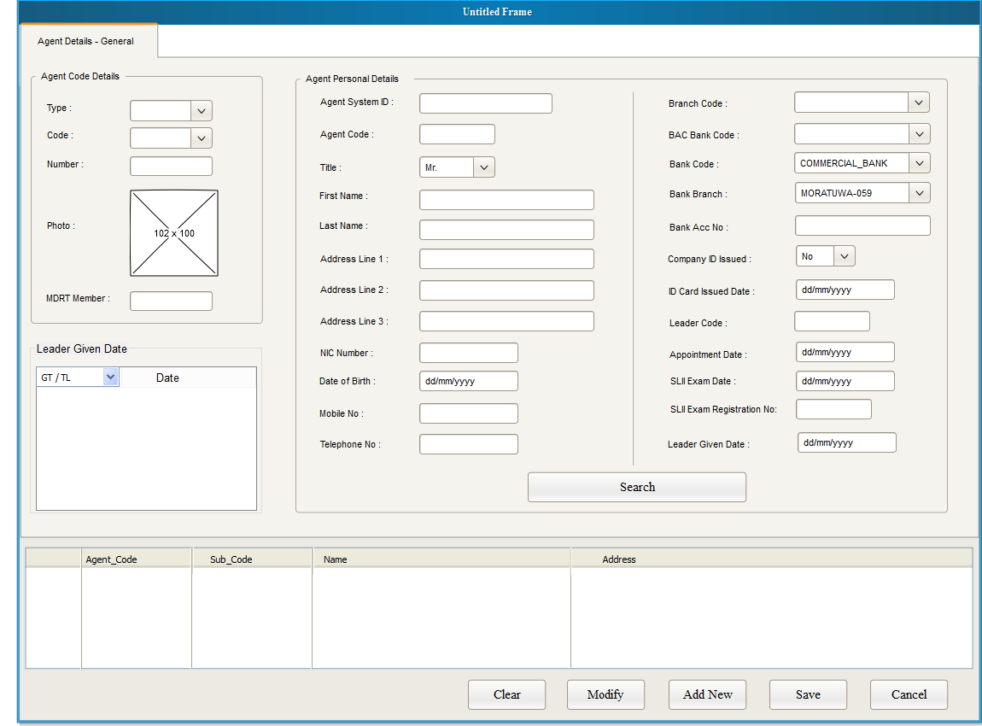

1. Agent Other Details

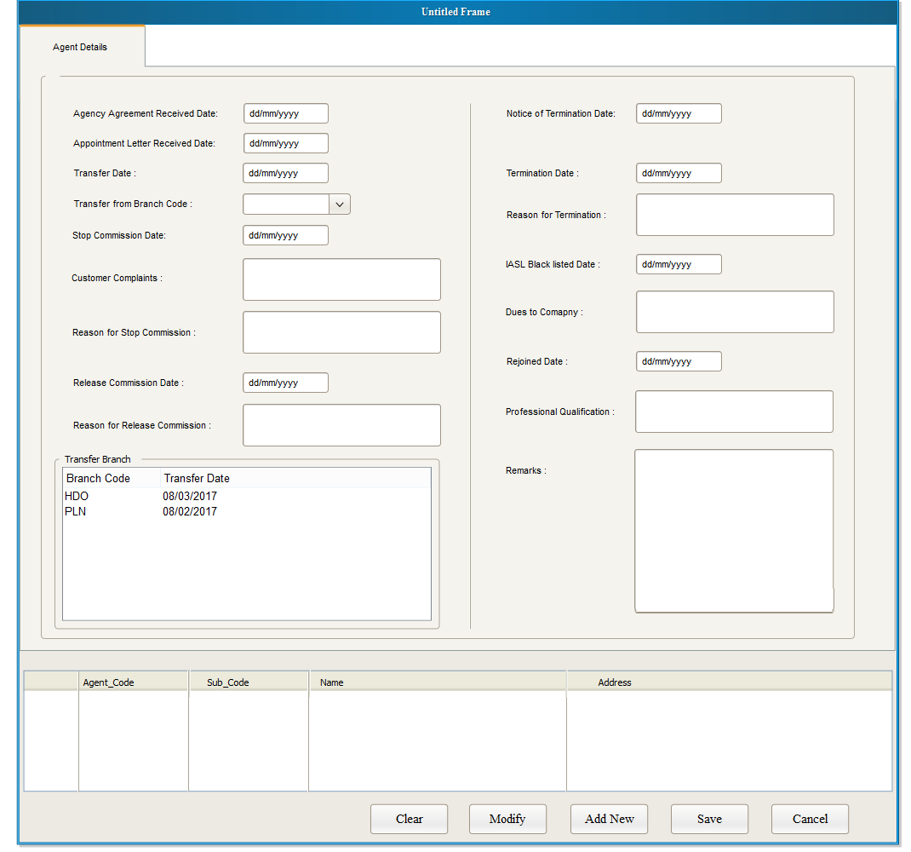

1. Agent Level Details

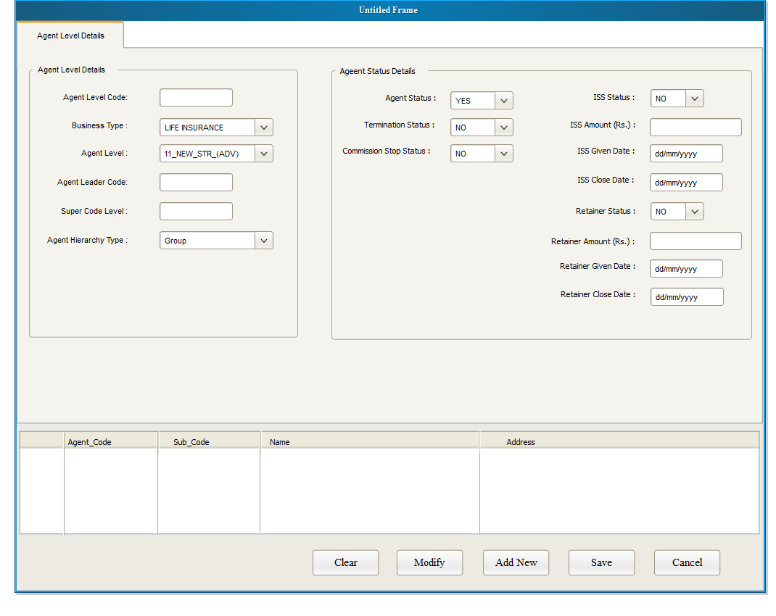

## 

Interface 03 – Document upload and viewer

1. Commission Rule Define Interface

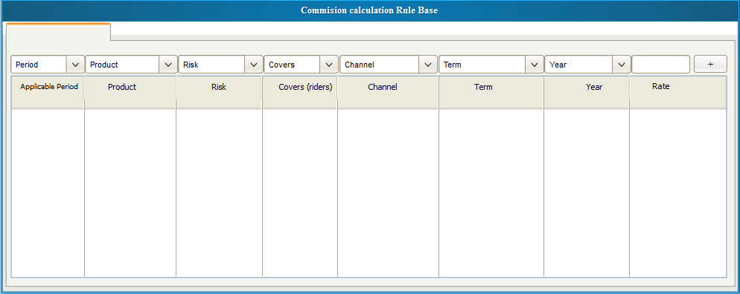

1. Commission Overriding Rule Define Interface

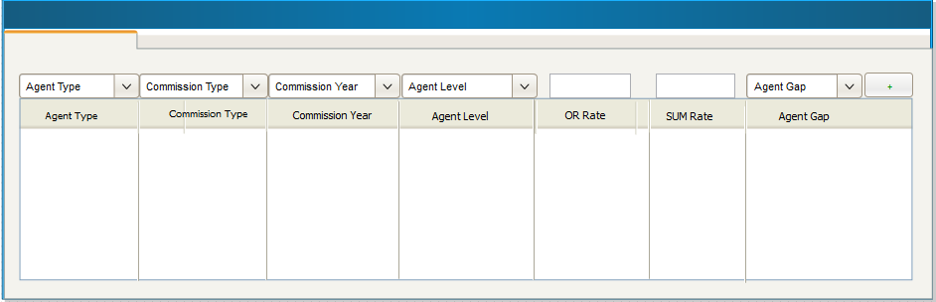

1. Bank Assurance Detail Management

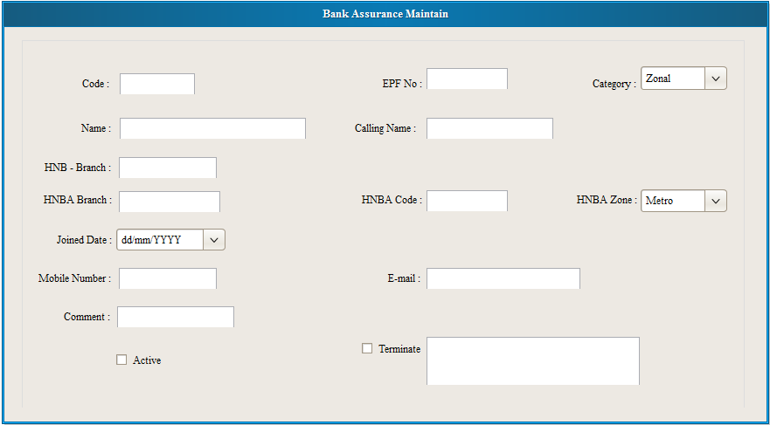

**Reports**

Servicing unit reports List - (Date Range)

1. Commission Admin Expense GWP NON BAC
2. Commission Admin Expense GWP BAC
3. Cheque Returns Report
4. Refund Report
5. Main Data Base Report
6. Main Data TME
7. PID Life
8. NONBAC Advisor Commission statement
9. TME Commission Statement
10. Transfer Summery
11. BAC Advisor commission statement
12. Opening Balance Statement
13. Refund / Cheque Return Schedule

Marketing Reports List

1. Advisor  Direct team report
2. Advisor Group  team report
3. Advisor main report
4. Advisor  report with date range
5. Policy report with date range  (Branch MIS)
6. Mobile numbers List
7. Title Mr./Mrs.- List from Gender
8. Stop commission reason List
9. Termination reason  List
10. Black list details List
11. Recoveries List
12. Preference Language

## . System Integration

## 

This system is working based on TCS data and few other systems. This will be calculating the agent commissions and incentives by taking TCS receipts (sys vouchers) & other systems DPTS details.

## Unsolved issues

1. TCS APIs is pending for to integrate New Commission app and TCS agent module.
2. TCS PID balance is correcting.

## Assumptions

* TCS will be providing API to communicate with Agent management module so that we would be able to avoid duplicate agent detail feeding.
* Cover level (Rider Level) commission will be calculating same as overriding commission calculation process since this is for extra covers and payment goes as an additional commission.
* For Non-TCS products, Until they come to systems (Applications) we have to continue the same process as now.(Upload DPTS files to new commission application)
* Please note that given interface designs may change when the time of implementation so please use those only for understanding purpose. Also For the incentive scheme there are no interface designs and flow charts given and there are more interfaces will be there more than attached.